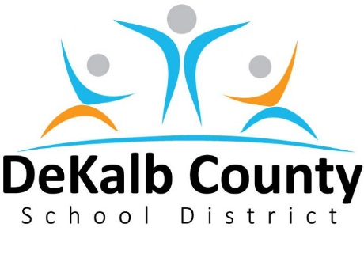
Media Alert
10 August 2016
1701 Mountain Industrial Boulevard
Stone Mountain, GA 30083-1027
Communications: 678-676-0720

SECONDARY SCHOOL FACILITY PLANNING AND FEASIBILITY
STUDY PUBLIC MEETINGS

Who: DeKalb County School District and Community Stakeholders
What: Two public input meetings for the Secondary School Facility Planning and Feasibility Study for middle schools and high schools. At these meetings staff will present recommendations for middle and high school feeder patterns, re-clustering attendance areas, additions to schools and new/replacement schools. An online feedback survey will be available at time below. Stakeholder feedback from these meetings and online survey will be incorporated into the 2017-2022 SPLOST list (Building S.P.A.C.E.S) later this Fall.
Note: The recommendations to be presented at these meetings will be available online Tuesday Aug 23 at noon at: http://www.dekalb.k12.ga.us/www/secondaryschoolfacilitystudy
Meeting 1: Clarkston High School Tuesday, August 23, 2016 at 6:30 PM
618 N. Indian Creek Drive
Clarkston, GA 30021

Meeting 2: Cross Keys High School Thursday, August 25, 2016 at 6:30 PM
1626 N. Druid Hills Road NE
Atlanta, GA 30319

Online Survey: Tuesday Aug 23 at noon to Thursday September 8 at 11:59pm.

http://www.dekalb.k12.ga.us/www/secondaryschoolfacilitystudy

